Hfdst 7

7-28 Assumptions The heat pump operates steadily.
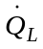

Analysis Since the heat pump is completely reversible, the combination of the coefficient of performance expression, first Law, and thermodynamic temperature scale gives
10°C
21°C
HP
100 kW
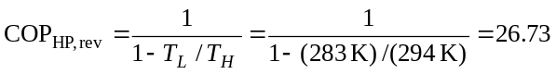
The power required to drive this heat pump, according to the coefficient of performance, is then
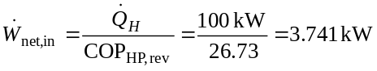
According to the first law, the rate at which heat is removed from the low-temperature energy reservoir is
The rate at which the entropy of the high temperature reservoir changes, according to the definition of the entropy, is
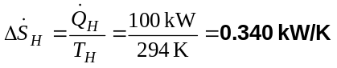
and that of the low-temperature reservoir is
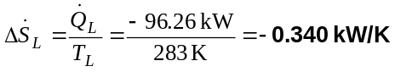
The net rate of entropy change of everything in this system is
as it must be since the heat pump is completely reversible.

7-33 According to the conservation of mass principle,
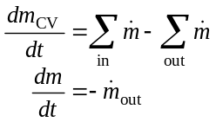
An entropy balance adapted to this system becomes
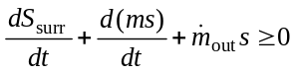
When this is combined with the mass balance, it becomes
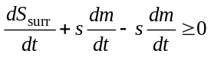
Multiplying by dt and integrating the result yields
Since all the entropies are same, this reduces to
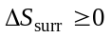
Hence, the entropy of the surroundings can only increase or remain fixed.

7-49 Assumptions 1 The system is stationary and thus the kinetic and potential energy changes are zero. 2 There are no work interactions involved other than the boundary work. 3 The thermal energy stored in the cylinder itself is negligible. 4 The compression or expansion process is quasi-equilibrium.
Analysis The energy balance for this system can be expressed as
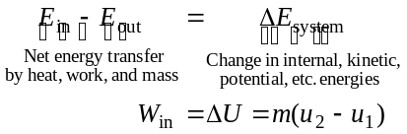
The initial state properties are
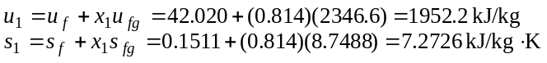
T
s
2
1
Since the entropy is constant during this process,
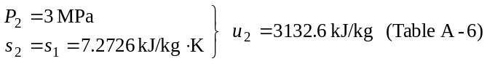
Substituting,

7-52 The total heat transfer for the process 1-2 shown in the figure is to be determined.
Analysis For a reversible process, the area under the process line in T-s diagram is equal to the heat transfer during that process. Then,
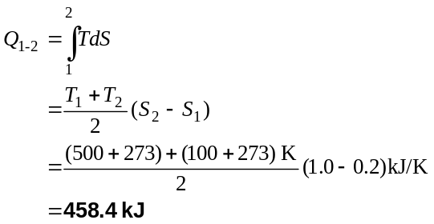
T (°C)
S (kJ/K)
2
1
500
100
0.2 1.0

7-55 Assumptions 1 This is a steady-flow process since there is no change with time. 2 The process is isentropic (i.e., reversible-adiabatic).
Analysis There is only one inlet and one exit, and thus 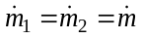. We take the turbine as the system, which is a control volume since mass crosses the boundary. The energy balance for this steady-flow system can be expressed in the rate form as
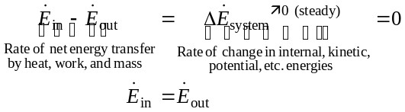
Turbine
2 MPa
360°C
100 kPa
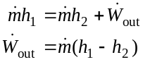
T
s
2
1
2 MPa
100 kPa
The inlet state properties are
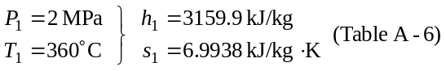
For this isentropic process, the final state properties are (Table A-5)
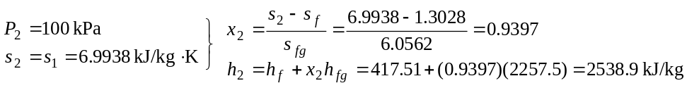
Substituting,
7-64 Assumptions 1 The system is stationary and thus the kinetic and potential energy changes are zero. 2 There are no work interactions involved. 3 There is no heat transfer between the system and the surroundings.
Analysis (a) The energy balance for this system can be expressed as
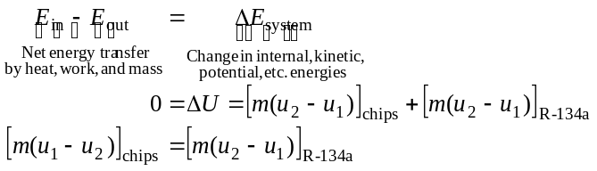
The heat released by the chips is
The mass of the refrigerant vaporized during this heat exchange process is
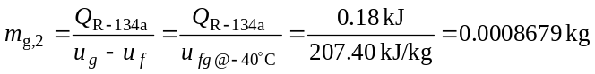
Only a small fraction of R-134a is vaporized during the process. Therefore, the temperature of R-134a remains constant during the process. The change in the entropy of the R-134a is (at -40°F from Table A-11)
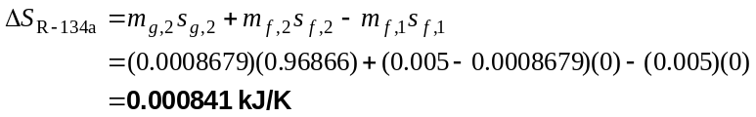
(b) The entropy change of the chips is
(c) The total entropy change is
The positive result for the total entropy change (i.e., entropy generation) indicates that this process is possible.

7-69 a) Using the entropy data from the compressed liquid water table: w_{p}=15,10 kJ/kg
b) Using inlet specific volume and pressure values: w_{p}=15,14 kJ/kg; Error = 0,3%
c) Using average specific volume and pressure values: w_{p}=15,10 kJ/kg; Error = 0%

7-78 Assumptions Helium and nitrogen are ideal gases with constant specific heats.
Properties The properties of helium are c_{p} = 5.1926 kJ/kg⋅K, R = 2.0769 kJ/kg⋅K (Table A-2a). The specific heat of nitrogen at the average temperature of (427+27)/2=227°C=500 K is c_{p} = 1.056 kJ/kg⋅K (Table A-2b). The gas constant of nitrogen is R = 0.2968 kJ/kg⋅K (Table A-2a).
Analysis From the entropy change relation of an ideal gas,
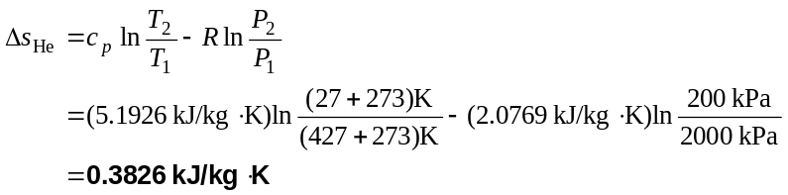
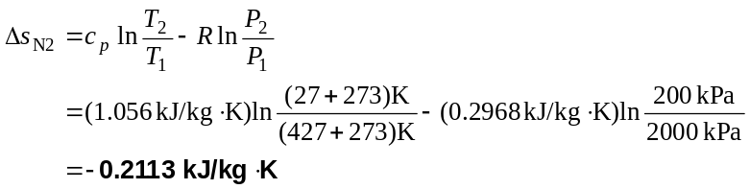
Hence, helium undergoes the largest change in entropy.

7-99 Assumptions 1 Kinetic and potential energy changes are negligible. 2 Air is an ideal gas with constant specific heats. 3 The room is well-sealed and there is no heat transfer from the room to the surroundings. 4 Sea level atmospheric pressure is assumed. P = 101.3 kPa.
Properties The properties of air at room temperature are R = 0.287 kPa.m³/kg.K, c_{p} = 1.005 kJ/kg.K, c_{v} = 0.718 kJ/kg.K. The specific heat of water at room temperature is c_{w} = 4.18 kJ/kg.K (Tables A-2, A-3).
Analysis (a) The mass of the air in the room is
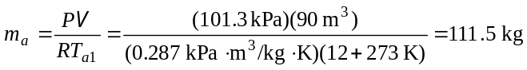
Water
45 kg
95°C
Room
90 m³
12°C
An energy balance on the system that consists of the water in the container and the air in the room gives the final equilibrium temperature
(b) The heat transfer to the air is
(c) The entropy generation associated with this heat transfer process may be obtained by calculating total entropy change, which is the sum of the entropy changes of water and the air.
